Chapter 11, Solution 45.

(a) 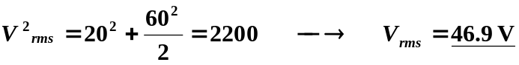
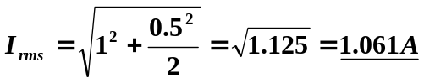

(b) p(t) = v(t)i(t) = 20 + 60cos100t – 10sin100t – 30(sin100t)(cos100t); clearly the average power = 20W.

